Name: Jude Anaman Company: Bracane Company Inc.

Analyzing and Summarizing Infant Formula Feeding Data from CSV Files
Introduction
In this article, I will delve into a Python script that processes infant formula feeding data from multiple CSV files. The script aggregates quarterly data for different states over a range of years, ultimately generating a summary CSV file that contains both state-specific and overall totals. This analysis is crucial for understanding trends in infant nutrition across various regions.
Key Concepts
The code leverages several fundamental concepts in Python programming, particularly in data manipulation and file handling. The primary libraries utilized include:
- Pandas: A powerful data manipulation library that facilitates the reading and processing of CSV files.
- CSV: A module for reading and writing CSV files, which is essential for data export.
- Math: A library that provides mathematical functions, such as checking for NaN (Not a Number) values.
- Pathlib and OS: Libraries that assist in file path management and directory operations.
Code Structure
The code is structured into several key components:
- Importing Libraries: Essential libraries are imported at the beginning.
- Initialization: Variables for year tracking and data storage are initialized.
- Data Processing Loop: A loop iterates through the specified years, reading CSV files and aggregating data.
- Data Aggregation: Within the loop, data is aggregated by quarters for each state.
- CSV Export: Finally, the aggregated data is written to a new CSV file.

Code Examples
Here is a breakdown of the code provided:
This script processes multiple CSV files containing quarterly data about formula-fed infants across different states and years, aggregates the data, and outputs a consolidated CSV file.
Details Breakdown:
- Import Statements
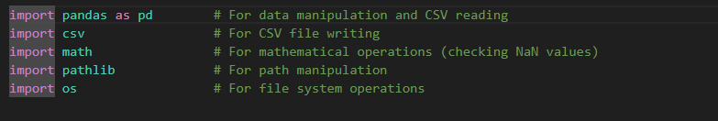
- Initial Setup
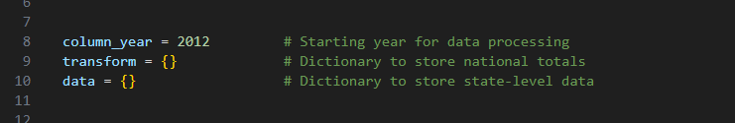
- Main Processing Loop
The code processes data from 2013 to 2016 (files 2013-2016):

- File Reading and Data Extraction

- 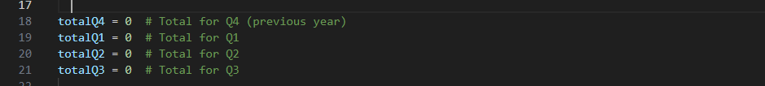Quarterly Totals Initialization
- 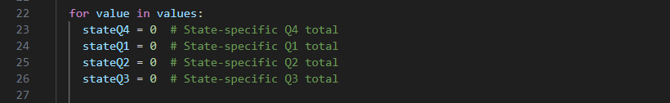State-Level Data Processing
For each row (state) in the data:

- Column Processing Logic
The code processes 15 columns:
Column 0: State name (used as key)
Columns 1-3: Q4 data (previous year)
Columns 4-6: Q1 data
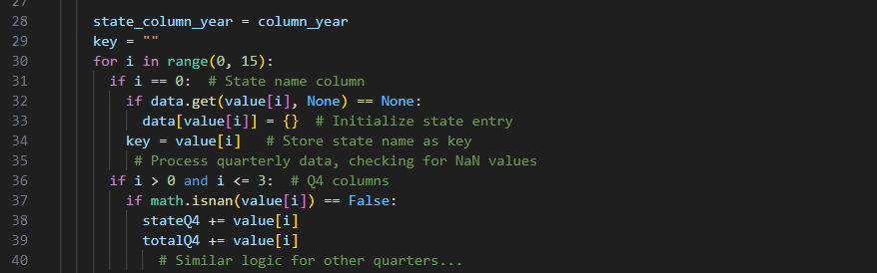Columns 7-9: Q2 data
Columns 10-12: Q3 data

- 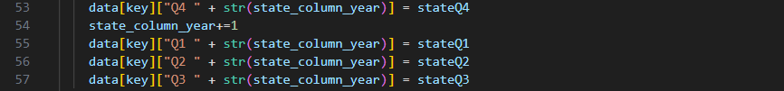Data Storage

- 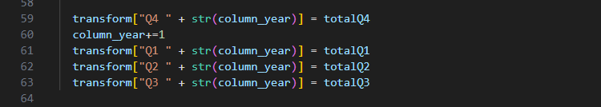National Totals
- Final Data Preparation

- Output File Creation
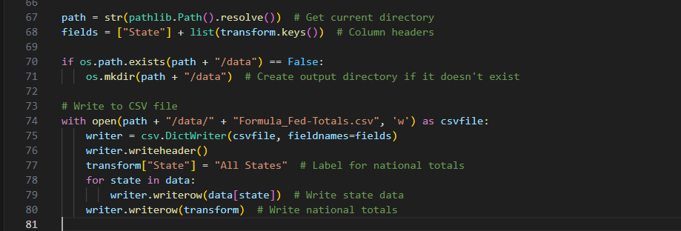
Explanation of Key Sections:
- Data Reading: The code reads CSV files for the years 2012 to 2015, extracting data on infants who are fully formula-fed.
- Aggregation Logic: For each state, the code calculates the total number of formula-fed infants for each quarter, while also maintaining a cumulative total across all states.
- Handling NaN Values: The code employs math.isnan() to ensure that only valid numerical entries are considered in the aggregation.
- CSV Writing: The final aggregated data is written to a new CSV file, ensuring that the results are easily accessible for further analysis.

Output Structure
The final CSV will have:
- Rows: Each state + "All States" row for national totals
- Columns: State name + quarterly columns (Q4 2012, Q1 2013, Q2 2013, Q3 2013, Q4 2013, etc.)

Conclusion
The provided Python code serves as a robust framework for aggregating and exporting data related to infants who are fully formula-fed across various states. By utilizing libraries such as Pandas and CSV, the code efficiently processes large datasets, ensuring that the results are both accurate and readily available for analysis. This approach not only highlights the importance of data manipulation in Python but also underscores the potential for further enhancements, such as data visualization or integration with databases for more complex analyses.

